**Chapter I**

**INTRODUCTION**

One of the most important organs of the body is Heart. It consists of the atrium and ventricles. The heart is responsible for the pumping of blood through the network of arteries and veins called the cardiovascular system all over the body. The heart has four chambers:

* The right atrium receives blood from the veins and pumps it to the right ventricle.
* The right ventricle receives blood from the right atrium and pumps it to the lungs, where it is loaded with oxygen.
* The left atrium receives oxygenated blood from the lungs and pumps it to the left ventricle.
* The left ventricle (the strongest chamber) pumps oxygen-rich blood to the rest of the body. The left ventricle’s vigorous contractions create our blood pressure.

Heart disease is one of the most common cause of death among Filipinos. “21 percent of Filipino adults are hypertensive,” said Dr. Dante Morales, President of the Philippine Society of Hypertension (PSH) during the National Hypertension Awareness celebration conducted at the Universidad De Manila on 19 May 2012.

Blood Pressure is the pressure circulating blood on the walls of blood vessels. Blood pressure is usually expressed in terms of the systolic pressure (maximum during one heart beat) over diastolic pressure (Minimum in between two heart beats) and is measured in millimeters of mercury (mmHg). Normal resting blood pressure in an adult is approximately 120 mmHg systolic, and 80 mmHg diastolic, abbreviated “120/80 mmHg”. Blood pressure has two states the low blood pressure also known as the hypotension and hypertension for the high blood pressure. Long term hypertension can affect the body it is a risk factor for many diseases, including heart disease, stroke, and kidney failure. Heart rate is one of the vital signs. It is the number of times per minute that the heart contracts or beats. The resting heart rate is the rate where you’re sitting or lying and when you’re calm it is said that the heart rate is normally between 60 (beats per minute) and 100 (beats per minute).

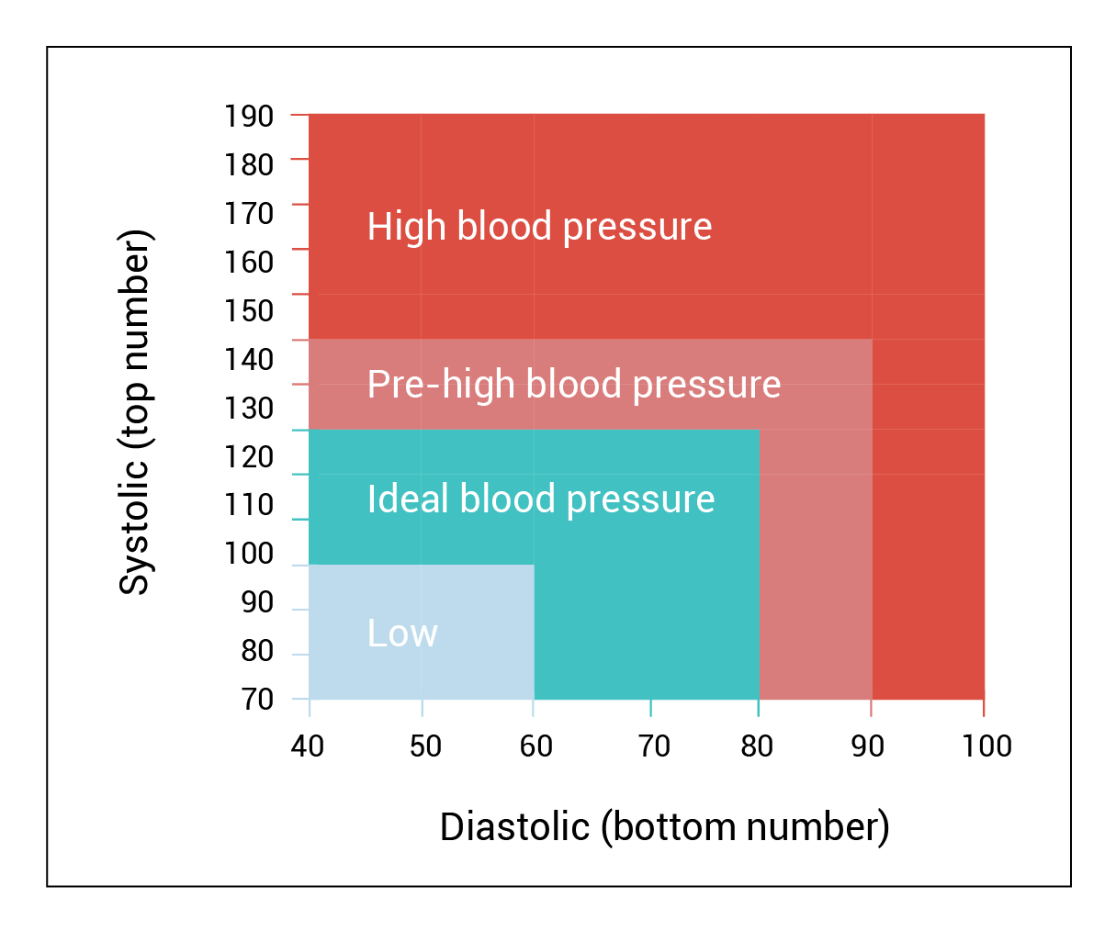

**Fig. I General Blood Pressure Chart**

Blood pressure and heart rate are interrelated components of the cardiovascular system and therefore, not mutually exclusively. One can affect another according to, ”Dr. Shelby-Lane. If the blood pressure is not monitored properly the arteries and the vital organs in the body will be damaged causes heart attack, stroke, heart failure, aneurysm or renal failure. Which means there is a need for the patients’ family members, friends and communities to involve in the care activities.

Monitoring of the blood pressure is important for the vital prevention and treatment of blood pressure related disease. Additionally, in very ill patient, accurate measurement of blood pressure is essential for monitoring cardiovascular homeostasis. The traditional way of measuring of blood pressure is with the use of cuff has a gauge on it that will read your blood pressure. Then the doctor or nurse will inflate the cuff to squeeze your arm.

After the cuff is inflated, the doctor or nurse will slowly let air out. While doing this, he or she will listen to your pulse with a stethoscope and watch the gauge. The gauge uses a scale called "millimeters of mercury” (mmHg) to measure the pressure in your blood vessels.

Blood pressure is measured using two numbers. The first number, called **systolic** blood pressure, measures the pressure in your blood vessels when your heart beats. The second number, called **diastolic** blood pressure, measures the pressure in your blood vessels when your heart rests between beats.

If the measurement reads 120 systolic and 80 diastolic, you would say "120 over 80" or write "120/80 mmHg."

A blood pressure less than 120/80 mmHg is normal. A blood pressure of 140/90 mmHg or more is too high. People with levels in between 120/80 and 140/90 have a condition called prehypertension, which means they are [at high risk for high blood pressure](https://www.cdc.gov/bloodpressure/risk_factors.htm). The chart below shows normal, at-risk, and high blood pressure levels based on the patient age.

|  |  |  |  |  |  |  |  |  |  |  |
| --- | --- | --- | --- | --- | --- | --- | --- | --- | --- | --- |
| **Age** | **Hypotension (low blood pressure)** | | **Normal BP** | | **Prehypertension** | | **Hypertension Stage 1** | | **Hypertension Stage 2** | |
|  | S | D | S | D | S | D | S | D | S | D |
| 17-19 | < 90 | < 60 | <120 | <85 | <120 | <80 | <140 | <89 | <150 | <100 |
| 20-24 | < 90 | < 60 | <120 | <79 | <125 | <82 | <140 | <85 | <150 | <100 |
| 25-29 | < 90 | < 60 | <121 | <80 | <132 | <83 | <140 | <88 | <150 | <100 |
| 30 - 34 | < 90 | < 60 | <122 | <81 | <134 | <85 | <140 | <90 | <160 | <100 |
| 35 - 39 | < 90 | < 60 | <123 | <82 | <135 | <86 | <142 | <91 | <162 | <101 |
| 40 - 44 | < 90 | < 60 | <125 | <83 | <137 | <87 | <144 | <92 | <164 | <102 |
| 45 - 49 | < 90 | < 60 | <127 | <84 | <139 | <88 | <146 | <93 | <166 | <103 |
| 50 - 54 | < 90 | < 60 | <129 | <85 | <141 | <89 | <148 | <94 | <168 | <104 |
| 55 - 59 | < 90 | < 60 | <131 | <86 | <143 | <90 | <150 | <95 | <170 | <105 |
| 60+ | < 90 | < 60 | <134 | <87 | <146 | <91 | <153 | <96 | <173 | <106 |

**Fig. 1.2 Blood Pressure Chart by Age**

*S = Systolic Pressure*   
*D = Diastolic Pressure*

**Background of the Study**

The researcher became interested in picking this study because of their experiences in local health center. The doctors, nurses and barangay health workers are the one who is capable of reading the blood pressure. And when the patient need to know his/her blood pressure and heart rate they must go to nearest health center or hospital but if there are so many patients it will take time to finish measuring everyone’s blood pressure while some other people practice reading their own or others blood pressure using the traditional way with the use of stethoscope and brachial pressure cuff this study will help to lessen the human error from misinterpreting because of the failure to identify the Korotkoff sounds that can lead to over and under estimation of the blood pressure. Also, it can help to conserve time because to have an accurate reading of the blood pressure you must go to the clinic or hospital

High blood pressure (hypertension) can quietly damage your body for years before symptoms develop. Left uncontrolled, you may wind up with a disability, a poor quality of life or even a fatal heart attack. Roughly half the people with untreated hypertension die of heart disease related to poor blood flow (ischemic heart disease) and another third die of stroke.

In this study, we design a monitoring device that will allows the patient to measure their heart rate and blood pressure. The system will notify the patient or the user if the system detects abnormalities such as low blood pressure, pre-high blood pressure and high blood pressure in the measurement. Different features will be added to the to the system that will be beneficiary to the elders. The researchers will add a printing system that enables the user to print the measurement so that if the patient is monitored in home it can keep a better record to give to his/her doctor.

This study will gather the measurements and store the data in an organize way to see the record and monitor easily.

**OBJECTIVES**

The general objective of this study is to develop a system that measure and monitor the blood pressure, heart rate.

1. To design a system that records the reading of blood pressure and heart rate

2. To determine the sensors that will be used in the system.

3. To compare the result of the traditional way with the automated way of measuring blood pressure and heart rate.

4. To test and evaluate the effectiveness and accuracy of the device.

**Significance of Study**

This study will be beneficial to the persons who have a high blood pressure or low blood pressure. This study will help to improve the accessibility of the device for the patient, so that the patient will able to monitor his/her blood pressure in a handy way anytime anywhere. This will also decrease the expenditures of the patient by consulting to the doctor or physician. This research will also lessen the risk of worsening the condition of the patient or user. One of the beneficial result this study is that to encourages the patient on being a health conscious by gaining responsibility to their own health, motivating for improved diet, physical activities and proper medication. This study could be a tool for keeping track of the user’s record.

**Scopes and Limitation**

This study includes creating a system that will only measure the blood pressure and pulse rate of the user for monitoring and keeping record. This study will use sensors to get the measurement of blood pressure and heart rate. This study will also allow a multiple user so that other user can use the device without interfering the data of the other users. The application will allow the user to add his/her profile information for the betterment of keeping records.

The notification will be based on the age of the patient. If the system detects abnormalities in the result of measurements alert will be display on LCD with sound alarm so that the user will notify immediately in his/her condition.

This study also capable of printing the weekly and monthly reading of the blood pressure and heart rate. The printing form will consist of the user’s name, age, the date and time the user conduct the reading, the result of the blood pressure and the heart rate.

**Definition of Terms**

1. **Android** is an operating system for smartphones and other devices, developed by Android, Inc. and later purchased by Google.

2. **Blood Pressure** is the pressure of the blood in the circulatory system, often measured for diagnosis since it is closely related to the force and rate of the heartbeat and the diameter and elasticity of the arterial walls.

3. **C programming language** is a programming language that is ideal for developing firmware or portable applications. It is a [procedural language](https://simple.wikipedia.org/w/index.php?title=Procedural_language&action=edit&redlink=1), which means that people can write their [programs](https://simple.wikipedia.org/wiki/Computer_program) as a series of step-by-step instructions.

4. [**Database**](https://en.wikipedia.org/wiki/Database) is the collection of [schemas](https://en.wikipedia.org/wiki/Database_schema), [tables](https://en.wikipedia.org/wiki/Table_(database)), [queries](https://en.wikipedia.org/wiki/Query_language), reports, [views](https://en.wikipedia.org/wiki/View_(SQL)), and other objects. The data are typically organized to model aspects of reality in a way that supports [processes](https://en.wikipedia.org/wiki/Process_(computing)) requiring information, such as modelling the availability of rooms in hotels in a way that supports finding a hotel with vacancies.

5. **Diastolic Pressure** is the blood pressure after the contraction of the heart while the chambers of the heart refill with blood.

6. **Hardware** is a comprehensive term for all of the physical parts of a computer, as distinguished from the data it contains or operates on, and the software that provides instructions for the hardware to accomplish tasks.

7. **Heart rate** is the speed of the heartbeat measured by the number of contractions of the heart per minute (bpm).

8. **Java** is a widely used programming language expressly designed for use in the distributed environment of the internet.

9. **Microcontroller** is a computer present in a single integrated circuit which is dedicated to perform one task and execute one specific application. It contains memory, programmable input/output peripherals as well a processor.

10. **Sensor** is an [electronic component](https://en.wikipedia.org/wiki/Electronic_component), module, or subsystem whose purpose is to detect events or changes in its environment and send the information to other electronics, frequently a [computer processor](https://en.wikipedia.org/wiki/Computer_processor).

11. **Software** is that part of a [computer system](https://en.wikipedia.org/wiki/Computer_system) that consists of [data](https://en.wikipedia.org/wiki/Data_(computing)) or computer instructions, in contrast to the [physical hardware](https://en.wikipedia.org/wiki/Computer_hardware) from which the system is built.

12. **Sphygmomanometer** is an instrument for measuring blood pressure in the arteries, especially one consisting of a pressure gauge and a nylonor rubber cuff that wraps around the upper arm and inflates to constrict the arteries.

13. **System** is a set of detailed methods, procedures and routines created to carry out a specific activity, perform a duty, or solve a problem.  
14. **Systolic Pressure** is specifically the maximum arterial pressure during contraction of the left ventricle of the heart.

15. **Personal health record (PHR)** is a collection of health-related information that is documented and maintained by the individual it pertains to.

16. **Pulse rate** is a rhythmical throbbing of the arteries as blood is propelled through them, typically as felt in the wrists or neck.

17. **Raspberry Pi** is a low cost, credit card sized computer that plugs into a computer monitor or TV, and uses a standard keyboard and mouse originally designed for education.